**Capstone Project - The Battle of Neighborhoods**

1. **Introduction**

This project is a kind of summary of the learned material covered in IBM course of data science. In this work, we used the algorithm – K-means clustering - applied to the neighborhoods in Toronto.

The objective of this Capstone is to learn about segmenting and k-means clustering, to understand how to use the Github platform, to learn the Foursquare API and to try to show the results of studying by publishing the final project on Github. The main goal is to understand the practical side of the application of techniques and algorithms of data science in real life tasks.

1. **Data**

The data has been collected from Wikipedia page, <https://en.wikipedia.org/wiki/List_of_postal_codes_of_Canada:_M> .

This html table was converted to Pandas DataFrame for cleaning and preprocessing. We have dropped the rows where Borough is 'Not assigned' and combined the neighbourhoods with same Postal code.

Then we have imported the csv file conatining the latitudes and longitudes for various neighbourhoods in Canada and merged two tables.

We will analyze all the rows from the data frame which contains Toronto in their Borough.

1. **Segmenting and Clustering Neighbourhoods in Toronto**

Wiki page contains 103 rows × 3 columns.

According to the merged table (Wiki + latitudes and longitudes for various neighbourhoods in Canada) we have found several neighbourhoods which contains Toronto.

Now we can visualize all the Neighbourhoods of the above data frame “Toronto” using Folium and the result we can see on the map:

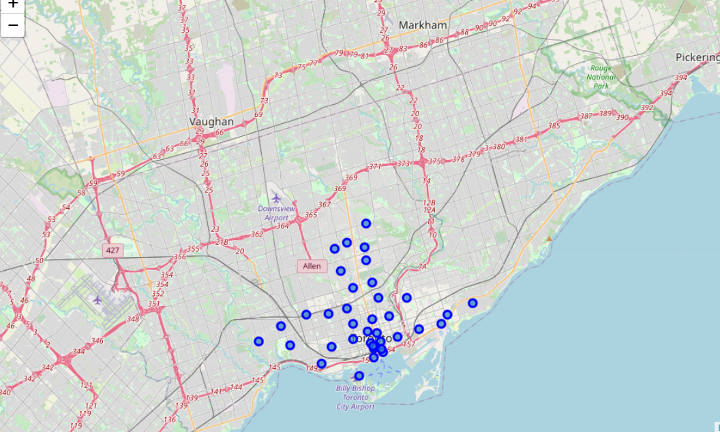

The first neighborhood's name in our data frame is 'The Beaches'.

|  |  |  |
| --- | --- | --- |
| **Name** | **Latitude** | **Longitude** |
| The Beaches | 43.67635739999999 | -79.2930312 |

Using Foursquare API we could get the top 100 venues that are in The Beaches within a radius of 500 meters.

|  |  |  |  |  |
| --- | --- | --- | --- | --- |
|  | **name** | **categories** | **lat** | **lng** |
| **0** | Glen Manor Ravine | Trail | 43.676821 | -79.293942 |
| **1** | The Big Carrot Natural Food Market | Health Food Store | 43.678879 | -79.297734 |
| **2** | Grover Pub and Grub | Pub | 43.679181 | -79.297215 |
| **3** | Upper Beaches | Neighborhood | 43.680563 | -79.292869 |

* 1. **Cluster neighborhoods**

For clustering we will use K—Means clustering method. The set number of clusters = 5.

By the next step we will create a new dataframe that includes the cluster as well as the top 10 venues for each neighborhood. Visualization of the resulting clusters is on the map below:

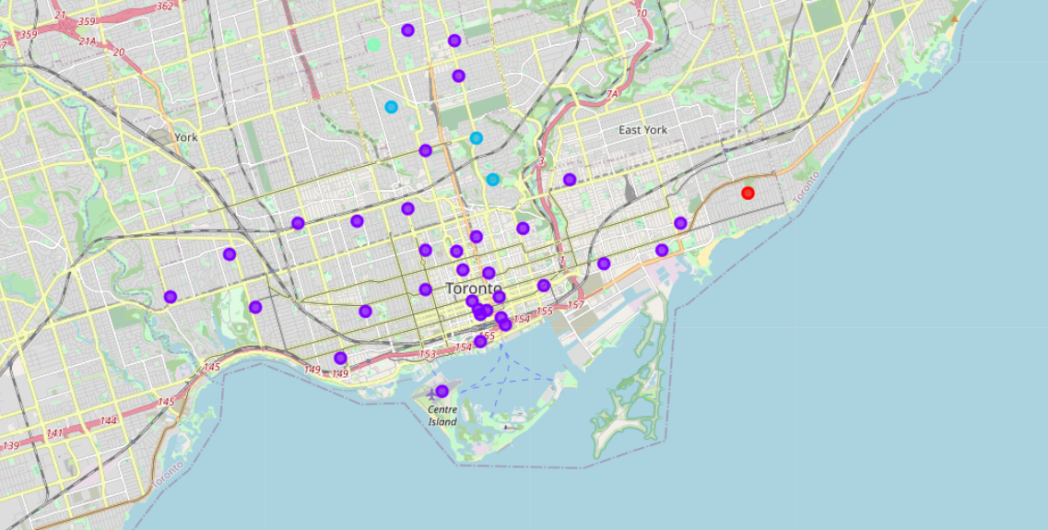

By the last step we will examine each cluster.

**Cluster 1**

|  |  |  |  |  |  |  |  |  |  |  |
| --- | --- | --- | --- | --- | --- | --- | --- | --- | --- | --- |
| Borough | 1st Most Common Venue | 2nd Most Common Venue | 3rd Most Common Venue | 4th Most Common Venue | 5th Most Common Venue | 6th Most Common Venue | 7th Most Common Venue | 8th Most Common Venue | 9th Most Common Venue | 10th Most Common Venue |
| East Toronto | Pub | Trail | Health Food Store | Wine Bar | Dog Run | Dessert Shop | Diner | Discount Store | Distribution Center | Donut Shop |

**Cluster 2**

|  |  |  |  |  |  |  |  |  |  |  |
| --- | --- | --- | --- | --- | --- | --- | --- | --- | --- | --- |
| **Borough** | **1st Most Common Venue** | **2nd Most Common Venue** | **3rd Most Common Venue** | **4th Most Common Venue** | **5th Most Common Venue** | **6th Most Common Venue** | **7th Most Common Venue** | **8th Most Common Venue** | **9th Most Common Venue** | **10th Most Common Venue** |
| East Toronto | Greek Restaurant | Coffee Shop | Italian Restaurant | Bookstore | Furniture / Home Store | Ice Cream Shop | Spa | Japanese Restaurant | Juice Bar | Brewery |
| East Toronto | Park | Fast Food Restaurant | Sushi Restaurant | Ice Cream Shop | Fish & Chips Shop | Italian Restaurant | Liquor Store | Movie Theater | Pet Store | Pizza Place |
| East Toronto | Coffee Shop | Brewery | Gastropub | Café | Bakery | American Restaurant | Yoga Studio | Convenience Store | Cheese Shop | Clothing Store |
| Central Toronto | Gym | Hotel | Park | Sandwich Place | Food & Drink Shop | Department Store | Dance Studio | Breakfast Spot | Gym / Fitness Center | Pizza Place |
| Central Toronto | Coffee Shop | Clothing Store | Pet Store | Seafood Restaurant | Salon / Barbershop | Restaurant | Café | Chinese Restaurant | Yoga Studio | Sporting Goods Shop |
| Central Toronto | Pizza Place | Dessert Shop | Sandwich Place | Sushi Restaurant | Café | Coffee Shop | Gym | Italian Restaurant | Farmers Market | Diner |
| Central Toronto | Coffee Shop | Pizza Place | Liquor Store | Restaurant | Pub | Bank | Supermarket | Bagel Shop | Fried Chicken Joint | Sushi Restaurant |
| Downtown Toronto | Restaurant | Café | Coffee Shop | Pizza Place | Bakery | Chinese Restaurant | Italian Restaurant | Pub | Park | Snack Place |
| Downtown Toronto | Coffee Shop | Sushi Restaurant | Japanese Restaurant | Restaurant | Gay Bar | Fast Food Restaurant | Yoga Studio | Café | Pub | Mediterranean Restaurant |
| Downtown Toronto | Coffee Shop | Park | Bakery | Café | Pub | Breakfast Spot | Theater | Cosmetics Shop | Shoe Store | Brewery |
| Downtown Toronto | Coffee Shop | Clothing Store | Hotel | Japanese Restaurant | Cosmetics Shop | Middle Eastern Restaurant | Café | Bubble Tea Shop | Theater | Bookstore |
| Downtown Toronto | Coffee Shop | Café | American Restaurant | Gastropub | Cocktail Bar | Gym | Clothing Store | Moroccan Restaurant | Lingerie Store | Seafood Restaurant |
| Downtown Toronto | Coffee Shop | Cocktail Bar | Bakery | Beer Bar | Farmers Market | Restaurant | Cheese Shop | Seafood Restaurant | Hotel | Basketball Stadium |
| Downtown Toronto | Coffee Shop | Italian Restaurant | Café | Sandwich Place | Salad Place | Thai Restaurant | Burger Joint | Bubble Tea Shop | Ramen Restaurant | Portuguese Restaurant |
| Downtown Toronto | Coffee Shop | Café | Restaurant | Clothing Store | Deli / Bodega | Hotel | Thai Restaurant | Gym | Pizza Place | Burrito Place |
| Downtown Toronto | Coffee Shop | Aquarium | Café | Hotel | Scenic Lookout | Restaurant | Brewery | Italian Restaurant | Fried Chicken Joint | History Museum |
| Downtown Toronto | Coffee Shop | Hotel | Café | Restaurant | Italian Restaurant | Japanese Restaurant | Seafood Restaurant | Salad Place | American Restaurant | Deli / Bodega |
| Downtown Toronto | Coffee Shop | Restaurant | Café | Hotel | Gym | American Restaurant | Italian Restaurant | Japanese Restaurant | Deli / Bodega | Seafood Restaurant |
| Central Toronto | Sandwich Place | Café | Coffee Shop | Donut Shop | Middle Eastern Restaurant | Pub | Liquor Store | BBQ Joint | Indian Restaurant | History Museum |
| Downtown Toronto | Café | Bookstore | Bar | Japanese Restaurant | Bakery | Sandwich Place | Beer Bar | Beer Store | Italian Restaurant | Comfort Food Restaurant |
| Downtown Toronto | Café | Coffee Shop | Vegetarian / Vegan Restaurant | Vietnamese Restaurant | Mexican Restaurant | Bar | Gaming Cafe | Grocery Store | Bakery | Caribbean Restaurant |
| Downtown Toronto | Airport Lounge | Airport Terminal | Boutique | Harbor / Marina | Boat or Ferry | Rental Car Location | Plane | Coffee Shop | Sculpture Garden | Airport Service |
| Downtown Toronto | Coffee Shop | Seafood Restaurant | Cocktail Bar | Restaurant | Japanese Restaurant | Italian Restaurant | Beer Bar | Hotel | Café | Gym |
| Downtown Toronto | Coffee Shop | Café | Hotel | Gym | Japanese Restaurant | Restaurant | Salad Place | Seafood Restaurant | Deli / Bodega | Steakhouse |
| Downtown Toronto | Grocery Store | Café | Park | Candy Store | Restaurant | Baby Store | Italian Restaurant | Coffee Shop | Nightclub | Diner |
| West Toronto | Pharmacy | Bakery | Bus Stop | Bar | Grocery Store | Music Venue | Bank | Park | Supermarket | Coffee Shop |
| West Toronto | Bar | Coffee Shop | Vegetarian / Vegan Restaurant | Asian Restaurant | Restaurant | Vietnamese Restaurant | Café | Men's Store | Wine Bar | Korean Restaurant |
| West Toronto | Café | Coffee Shop | Breakfast Spot | Gym | Stadium | Burrito Place | Restaurant | Climbing Gym | Pet Store | Bakery |
| West Toronto | Café | Mexican Restaurant | Thai Restaurant | Speakeasy | Diner | Bar | Flea Market | Bakery | Fried Chicken Joint | Italian Restaurant |
| West Toronto | Breakfast Spot | Gift Shop | Dessert Shop | Cuban Restaurant | Eastern European Restaurant | Dog Run | Italian Restaurant | Bar | Restaurant | Movie Theater |
| West Toronto | Café | Coffee Shop | Pub | Pizza Place | Sushi Restaurant | Italian Restaurant | Gym | Gourmet Shop | Restaurant | Latin American Restaurant |
| Downtown Toronto | Coffee Shop | College Cafeteria | Sushi Restaurant | Gym | Fast Food Restaurant | Restaurant | Portuguese Restaurant | Park | Nightclub | Mexican Restaurant |
| East Toronto | Light Rail Station | Yoga Studio | Garden Center | Farmers Market | Fast Food Restaurant | Burrito Place | Restaurant | Brewery | Auto Workshop | Garden |

**Cluster 3**

|  |  |  |  |  |  |  |  |  |  |  |
| --- | --- | --- | --- | --- | --- | --- | --- | --- | --- | --- |
| **Borough** | **1st Most Common Venue** | **2nd Most Common Venue** | **3rd Most Common Venue** | **4th Most Common Venue** | **5th Most Common Venue** | **6th Most Common Venue** | **7th Most Common Venue** | **8th Most Common Venue** | **9th Most Common Venue** | **10th Most Common Venue** |
| Central Toronto | Park | Trail | Playground | Tennis Court | Wine Bar | Dog Run | Dessert Shop | Diner | Discount Store | Distribution Center |
| Downtown Toronto | Park | Trail | Playground | Dance Studio | Escape Room | Electronics Store | Eastern European Restaurant | Donut Shop | Doner Restaurant | Dog Run |
| Central Toronto | Park | Trail | Jewelry Store | Sushi Restaurant | Wine Bar | Dessert Shop | Ethiopian Restaurant | Escape Room | Electronics Store | Eastern European Restaurant |

**Cluster 4**

| **Borough** | **1st Most Common Venue** | **2nd Most Common Venue** | **3rd Most Common Venue** | **4th Most Common Venue** | **5th Most Common Venue** | **6th Most Common Venue** | **7th Most Common Venue** | **8th Most Common Venue** | **9th Most Common Venue** | **10th Most Common Venue** |
| --- | --- | --- | --- | --- | --- | --- | --- | --- | --- | --- |
| Central Toronto | Home Service | Garden | Wine Bar | Department Store | Event Space | Ethiopian Restaurant | Escape Room | Electronics Store | Eastern European Restaurant | Donut Shop |

**Cluster 5**

| **Borough** | **1st Most Common Venue** | **2nd Most Common Venue** | **3rd Most Common Venue** | **4th Most Common Venue** | **5th Most Common Venue** | **6th Most Common Venue** | **7th Most Common Venue** | **8th Most Common Venue** | **9th Most Common Venue** | **10th Most Common Venue** |
| --- | --- | --- | --- | --- | --- | --- | --- | --- | --- | --- |
| Central Toronto | Park | Bus Line | Swim School | Falafel Restaurant | Ethiopian Restaurant | Escape Room | Electronics Store | Eastern European Restaurant | Donut Shop | Doner Restaurant |

1. **Conclusion**

During these 5 weeks we have understand the basics of K-Means Clustering, using of Foursquare API and repository of Github.

We have got 5 different clusters of Toronto. The most common venues are:

|  |  |  |  |
| --- | --- | --- | --- |
| **Cluster** | **1st Most Common Venue** | **2nd Most Common Venue** | **3rd Most Common Venue** |
| 1 | Pub | Trail | Health Food Store |
| 2 | Coffee Shop | Restaurant | Café |
| 3 | Park | Trail | Playground |
| 4 | Home Service | Garden | Wine Bar |
| 5 | Park | Bus Line | Swim School |